Newsletter – Summer 2022 Issue
STAFF NEWS

LEAVERS:
Vicky Lack ANP (Advanced Nurse Practitioner) has left the practice in order that she can focus her attention to her academic teaching and other roles.
Claire Snowden (Medical Secretary) left Beech House to explore an opportunity within a family business and Ann Pullan (Medical Secretary) retired in April after 17 years at the practice. Both will be sadly missed by us all.
Sue Head (Phlebotomist) retired at the end of May and will be sorely missed by many patients who have encountered her expert blood taking skills!

STARTERS:

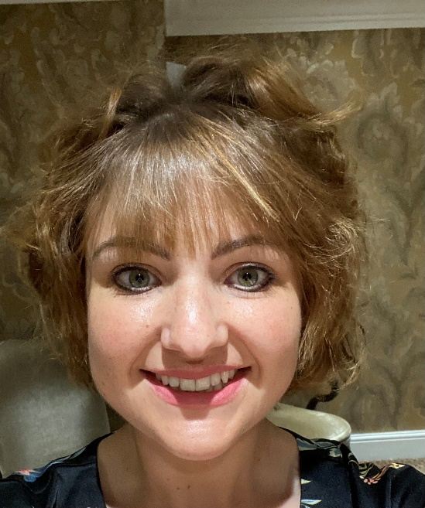
Sophie Bygate ANP joined the team in May and works three and a half days a week.
Sophie brings a wealth of experience gained initially in nursing, district nursing and most recently as an ANP in a large practice in Bradford and has already proved to be a fantastic permanent addition to our clinical team!

STARTERS:
Dr Dan Townley, our first GP Registrar joined us in February for 6 months as part of our clinical team. He has settled in very well and already is proving popular with the patients with his welcoming and reassuring manner. Dr Charlotte Jones and Dr Ian Marfell are Dan’s mentors having both qualified as Associate GP Trainers at the beginning of this year. Our next GP Registrar will be Isobel Fox, starting in September.
The last of our FY2 doctors for the 2021/22 rotation is Dr Sam Gallagher, he will be with us until the end of July when he will take up a post in Harrogate hospital A&E.
Jo Russell joined the team as a Medical Secretary in April. She has a wealth of experience from working at HDFT and has really got stuck in as a valuable member of the team.
Justine De Taure joined the practice in December as a Locum Medical Receptionist and brought with her a lot of hands-on experience from working in local practices.

PRIMARY CARE NETWORK (PCN) STAFF:
These are staff who work across the practices in Knaresborough and Rural PCN)
In addition to Jo Ball our current FCP (First Contact Practitioner) on a Wednesday and Thursday we have now got an additional FCP Jenny Albrayk who works at the practice on a Tuesday morning.
Martina Halstead has joined at PCN level as a Pharmacy Technician and will be working with the practice 1 day a week in addition to Adil and Rifat our current Clinical Pharmacists.
We have also now welcomed Siama Kausar, Senior Clinical Pharmacist, who will manage the pharmacy team across the PCN and work with us one day a week.
Through Knaresborough and Rural PCN will be soon have access to a Health and Wellbeing Coordinator, a Mental Health professional and other roles going forward.

OTHER STAFF NEWS:
Deb Garside and Helen Firth (Practice Nurses) have reduced their working hours but are still both with us 2 days per week.
We would like to take this opportunity to say a big thank you to Lynne Bradley our Practice Cleaner – who has been working for us for 25 years this month!

SERVICES

PUSH DOCTOR:
North Yorkshire CCG (Clinical Commissioning Group) have commissioned Push Doctor to provide practices with additional capacity for the next few months.
Push Doctor provide remote consultations which are suitable for patients with a smartphone/tablet.

All consultations are F2F (Face 2 Face) via video through the Push Doctor App and the Doctors can refer, prescribe, do fit notes etc.
All GPs are currently employed in general practice for the NHS in addition to working for Push Doctor. Patients can upload pictures during consultations. This service is new and we are currently signposting the service to suitable patients who call for an appointment.
The latest National GP Survey is open and some of you will have received letters/surveys to complete.
After attending an appointment you may be asked to complete a Family and Friends questionnaire.
The CQC (Care Quality Commission) were in touch with the practice earlier this year to say our rating remains the same. It is anticipated that CQC inspections will restart soon so lots of behind-the-scenes work is being undertaken to ensure we get the best inspection report possible when we get the call to say that they are coming – we work hard to provide the very best service for our patients, and we hope that our rating reflects that.

Access to the practice Dispensary has been restored now and you can access via the hatch in the waiting room.

As we move out of the COVID-19 pandemic we are removing some of the social distancing restrictions that were in place.

HEALTH UPDATE:
As we move out of the pandemic, we will start to offer more face-to-face appointments as well as telephone and video consultations.
The Flu campaign for 21/22 was very successful with an exceptionally high uptake. The vaccines for the 22/23 season have already been ordered and we will be holding clinics in October – more details for follow.
The COVID vaccination programme continued with a spring booster programme, and we were involved vaccinating our care home and housebound patients.
Ear syringing has restarted however Cryotherapy treatment will not recommence as there is very little clinical evidence to show it works. We have not restarted Spirometry as yet.

MEDEQUIP
MEDEQUIP is a company that loans equipment free of charge such as Wheeled adjustable frames; Adjustable walking sticks; Perching g stools; Raised toilet seat; Grab rails and much more to people who need these items. They are asking that you return the equipment when it is no longer needed.

You can contact Medequip to request a free and safe collection:
Call: 01423 226240 Email: north.yorks@medequip-uk.com or you can take it to their Medequip Knaresborough Depot; Unit 2, Manse Lane, Knaresborough, HG5 8LF.
Both local Waste and Recycling sites have the red wheelie bins to return equipment to.

INTERNATIONAL NURSES DAY:

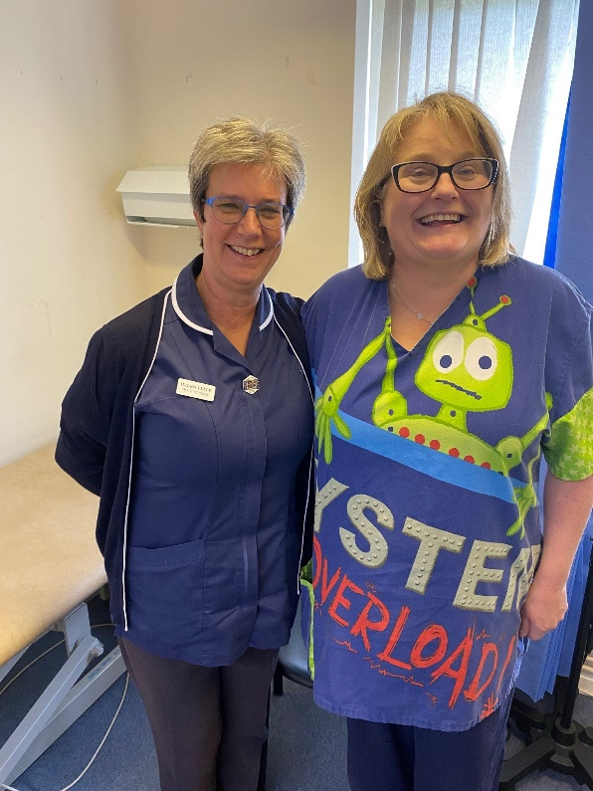

International Nurses Day took place on Thursday 12 May and we at Beech House are lucky to have such a dynamic and entertaining Nursing team. Here are Sisters Helen Firth and Rachel Poulter, just two of our Stars!

PATIENT PARTICIPATION GROUP (PPG)
Who are we?
We are a group of patients who wish to support and promote all that the Practice does. We have approximately four meetings a year including our AGM. Any patient of the Practice is welcome to attend the AGM which is held in September. We publish/advertise the date approximately a month in advance.
Earlier this year we heard the very sad news of the death of one of our group. Maggie Cowman had been a staunch supporter of the group and Beech House for many years. She worked tirelessly as the Chair of the group in her first stint as a member of the group and had recently re-joined as a member. We send our condolences to Maggie's’ family and friends. She will be sadly missed by us all.
The PPG can be contacted through – beechhousesurgery@nhs.net – Please mark your email with the heading “PPG”

FUTURE CONTENT:
Please let us know of any particular topic that you would like to see featured in our next Newsletter.

AND FINALLY…..

We would like to say a big thank you to the students and staff from St Johns Primary School in Knaresborough who kindly donated one of the cakes from their Jubilee Cake Competition – isn't it fantastic? It tasted amazing too
